Creative ways of sharing your family history:
Books:
- Decide what part of your family you want to write about
- Determine your focus:
- Are you writing about your family in general, a particular timeframe or a specific portion of one or more ancestor’s lives or experiences?
- You may want to create more than one book based on focus.
- Determine your audience:
- Is this for your family, the general public or both?
- What’s your target age?
- Determine organization of your book:
- Chronological?
- By family branch?
- Some combination?
- Choose the software program you’re going to use to write your book
- Download formatting and other requirements
- Download program, if applicable
- Envision the look for and length of your book
- This may be a function of audience age
- Portrait or landscape?
- Size
- Do you want to stick to a program’s format or create your own?
- Will this be an ebook, print or both?
- Start writing your draft
- As you proceed, choose your photos or artwork.
- If necessary, use a photo editing program to increase photo size and/or enhance the quality.
- Run through a program that increases DPI (dots per inch)
- Do fact-checking or further research as you run into conflicts or gaps in your research
- Write compelling chapter titles
- Write, rewrite and rewrite again… and again and again!
- Take a break! Sometimes coming back to what you’ve written can help you see where you can improve.
- Stuck? Frustrated? Need help? Consider running it through an AI program
- Upload the document (if it’s too large, you’ll need a paid program and there are limits there too, so you may have to split it up to work.
- Your prompt should be as specific as possible, such as: “Rewrite the document to be interesting and entertaining to a 5 year old.”
- Include in your prompt: “Retain all of the facts in the document.” Otherwise, the AI program will likely strip out quite a bit to make it – in the program’s opinion – more interesting.
- Do you need to acknowledge that you used AI? My opinion is that if it’s for your family, you don’t have to. If it’s for the general public and it’s more than a word choice here and there, you should.
- Choose photos and artwork
- Design and upload your cover. Write an interesting title.
- You may need to convert your book into a PDF that needs to be flattened – that sets in place all of the elements on the page (even though it looks to you like everything is set, it’s not). You most likely will have to use a paid program to do that (see below).

You might also have to check and increase your DPI – turns out, when you convert your document to a PDF, your photos lose resolution. You can do this in your PDF program (see links below)
- Use the Preview function of your program to be sure everything looks right, including page breaks, weird marks you might not have noticed, etc.
- Consider having someone else read your product in preview (or PDF) in case they have suggestions or catch something you might have missed.
- It’s scary, but it’s time to hit PUBLISH! Good news is you can always make changes and upload a new version but once you place an order, you’re locked in.

Book publishing websites:
Amazon: https://kdp.amazon.com/en_US/ -- Anyone can download or order. I.E., it is for public consumption.
Note: You can use their publishing/formatting program or upload your pdf with the formats you want. However, if you use the PDF version, device compatibility is slightly more limited to: Phones, computers, tablets, newer Kindles and Kindle Fire tablets.
Lulu: https://www.lulu.com/ You determine whether private or public
Blurb: https://www.blurb.com/ You determine whether private or public
Photo Books and Calendars in Shutterfly
- Determine your theme or subject of the book. People? Recipes? Places? Etc.
- Choose photos.
- Be sure each photo has at least one dimension (height or width) is at least1800 pixels – you can adjust using a photo editing program (link below to the one I use). Save and download at the highest quality.
- Consider using the Sharpen function to improve image quality
- Run each photo through the DPI converter. I’d suggest choosing 400 DPI.
- Go to Shutterfly.com:
- Photo books: https://www.shutterfly.com/photo-books/
- Calendars: https://www.shutterfly.com/calendars/
- Choose the size of your book or calendar.
- Choose your template or Create Your Own. With the calendar, you can choose the number of photos you want for each month and for the cover.
- Add photos.
- Shutterfly will let you know if a photo resolution is not high enough (I believe it’s an orange circle with an ! in the middle). If this happens, go back to your photo editor, increase size and sharpen if necessary and upload the new photo.
- For a photo book, add text as desired. For a calendar, you can also add events – ancestors’ or relatives’ birthdays, anniversaries and other information.
- Run your book or calendar through Preview mode and make tweaks as desired.
- Your project is under the header in the righthand side of the page under Projects. Publish and order copies.

Photo books and calendar websites:
Shutterfly:
Photo books: https://www.shutterfly.com/photo-books/
Calendars: https://www.shutterfly.com/calendars/
Blurb:
Photo books: http://www.blurb.com/photo-books
Lulu:
Photo books: https://www.lulu.com/create/photo-books
Calendars: https://www.lulu.com/create/calendars
Mixbook:
Photo books: https://www.mixbook.com/all-photo-books
Calendars: https://www.mixbook.com/photo-calendars-home
Snapfish:
Photo books: https://www.snapfish.com/photo-book
Calendars: https://www.snapfish.com/calendars

Cookbooks:
1. Find recipes – from your ancestors, relatives, native countries. Ask relatives if they have some.
2. Determine size, shape.
3. Determine organization of the book: By ancestor? By time of year/holiday? By country?
4. Determine format and content:
-- Scan in handwritten recipe? Type it in? Both?
-- Include background on the ancestor or shtetl or country
-- Include photographs of ancestor
-- Include photographs of the recipe preparation and finished product
5. Go to publishing website and pick your templates/follow instructions.
6. Print and order

Cookbook publishing websites:
Shutterfly: https://www.shutterfly.com/s/family-recipe-cookbook/
Lulu: https://www.lulu.com/create/cookbooks
Mixbook: https://www.mixbook.com/recipe-cookbook-photo-books
Snapfish: https://www.snapfish.com/s/cookbook?p=1
Blurb: https://www.blurb.com/cookbooks

Jigsaw Puzzles
1. Decide your focus: A person? A family? A town?
2. Pick template: One photo, multiple photos?
3. Make sure your photo resolution (DPI) and sizes are large enough.
4. Upload photos and place into template
5. Choose number of pieces. You can play around and see how many pieces you want. Here are the recommendations from Shutterfly:
60 pieces (10" x 14") — Ages 6+
252 pieces (10" x 14") — Ages 9+
520 pieces (16" x 20") — Ages 9+
1014 pieces (20" x 30") — Ages 9+
All sizes available in both portrait & landscape orientation
6. Preview puzzle, make needed adjustments
7. Order puzzle for print

Jigsaw Puzzle websites:
Shutterfly: https://www.shutterfly.com/s/jigsaw-puzzle-from-photo/
Snapfish: https://www.snapfish.com/s/jigsaw-puzzles-from-my-photo?p=1

Crossword Puzzles
1. Determine your focus – one side of your family? The entire family?
2. Research to find clues about your ancestors
3. Remember: The puzzle isn’t designed to stump people, it’s designed to engage and educate them, so you will likely need to include hints on clues that they aren’t likely to otherwise guess. The other possibility is that you use it as a supplement to a book rather than a standalone.
4. Input clues and answers into crossword puzzle maker. There are many crossword puzzle websites that allow you to create a puzzle for free but most require a paid plan to do things like print or download. I found a good, truly free site called Wordize that gives you multiple formats for downloading and that automatically generates the crossword grid.4. Right click Preview button to see variety of layouts.
5. Download blank puzzle and puzzle with answers

You can slightly increase the size of the squares in Word by doing the following:
- Change orientation: Go to Layout tab and under Orientation, choose Landscape.
- Change top margin: Go to Layout tab, click on Margins and select Custom margins. Reduce Top margin to 0.5”
- Select the Table: Click on the small "plus" icon (+) at the top-left corner of your crossword grid to select the entire table.
- Go to the Layout Tab: Look at the top ribbon in Word. You will see "Table Design" and “Table Layout". Click on Table Layout.
- Set Cell Size: Find the Cell Size section.
Height: Change the value. Play around with cell size. I could only increase size to 0.3 to keep puzzle on one page
Width: Change the value to the same size as height. 0.5" (or 1.3 cm).
6, Center the Numbers: While the table is still selected, look for the Alignment section in the Table Layout tab.
Click the Top-Left or Center-Left align button so the small numbers (1, 2, 3...) stay in the corner or center them if you prefer.

Crossword Puzzle website:
Truly free site: https://www.wordize.app/crosswordmaker/. This program generates the crossword puzzle based on your words and clues. A few programs on the web give you a blank grid and you have to figure out the layout for yourself. That’s a little too much work for me. Free = limits you on how many requests (e.g. downloads) you can make in a day.
Create an account before building so you don’t lose what you’ve done.
If you click the right arrow for Preview, it’ll give you different layouts to choose from.
You can save it in different formats. If you save it to PDF or jpg, you’re going to have to print it out for people to put in answers unless you have a paid program that can convert it. If you want folks to fill out the answers on the computer, save it as a Word file (docx or doc). You can use the tab button or right arrow to fill out Across answers and the down arrow for the down answers.
Note: If something is off when you download it – like a clue that is blank, try downloading again and it likely will resolve itself.

Audio
Audacity is a free program that you can download to your computer. Sound quality is best if you use headphones with a microphone.
To get started, you’ll still need to follow some of the same steps as with a book:
- Determine what part of your family to talk about
- Determine your focus
- Determine your audience
- If you’re comfortable writing a script, that might make the experience more smoothly
- On the other hand, if you’re comfortable just talking, go for it!
- Suggest limiting length – people’s attention only goes for so long!
- If you’re going to use a microphone, plug that in before opening Audacity.
- Click Edit and select Preferences.
- On this screen, select Start recording. As you record and when it’s done, you’ll see the sound waves across the screen.
- Choose Windows WASAPl under Host.
- If you have a headset microphone or standalone microphone, go to Recording Device and select the correct device.
- When you’re done, you can save to Audacity or export to your computer or other location.
To export:
Under File, choose Export Audio
Choose Share to audio.com or On your computer
Click Export to computer
Give it a file name and where you want it saved
Format defaults to WAV but you can change to others, such as MP3
Click Export
Audio websites:
Audacity: Download app here: https://www.audacityteam.org/
Audacity reference manual: https://manual.audacityteam.org/index.html
9-minute tutorial video: https://www.youtube.com/watch?v=C_mHOHv28Ic
Search YouTube for other videos on Audacity
Convert your Zoom interview to Audacity: https://youtube.com/watch?v=hoRaFfI1axw&si=OlYDyKa17teI4E6h
Royalty-free music for downloading:
https://pixabay.com/music/

Videos
1. For AI generated videos, determine your prompts and whether you it to convert photos to video or text to video.
2. For Video Slideshows using Animoto:
- Write the text that will be shown on each slide. Keep text as short as possible.
- Choose photos and other media
- Go to program, click Create a video and choose template
- Upload photos and other media
- Place into template along with text
- Choose your music from the library or upload your own
- Revise, if necessary, time slide stays on the screen and consider shortening text if it is too much
- It’s best to limit each video to 2 minutes max to keep the viewers’ attention
- Publish, download and share

Video websites:
AI Generated video generators include:
Sora2 (By ChatGPT): https://sora-2.run/generator
LTX: https://app.ltx.studio/
Free versions of these are limited in functionality. Generally, you get “credits” each day and they run out quickly. Veo 3, which is by Google, requires minimum of 60 credits to generate an 8 second video but only gives you 30 upon signing in, forcing you to pay if you want to generate a photo.
Most of these AI video generators want your email before you can do anything.

Video slideshow:
Animoto: https://animoto.com/
You must pay to publish, download and share videos but you can sign up for a monthly plan and cancel before the next billing period.
Microsoft has a slideshow maker called Clipchamp but it is VERY user-unfriendly

Rule of thumb: Many websites say “try for free” or just “free” but the rule of thumb is if they have a tab at the top labeled “Pricing,” you’re not going to be able to use it for free. Even if it doesn’t have pricing listed, most require your email address, often severely limit the “credits” you get to create a video with the free version.

Design tool websites:
Design your cover:
Usually, you’ll have to upload a pdf of the cover template from the publishing program
https://www.canva.com/
Free photo editing program:
Ipiccy: https://ipiccy.com/app#editor
Also has design and collage features
DPI converter:
https://convert.town/image-dpi
PDF tools:
Adobe Acrobat Pro: https://www.adobe.com/acrobat/pricing.html
Trial version does not have all of the tools you need and it’s difficult to find free PDF tools online. I would suggest you buy one month to do what you need to do and then cancel.
To convert a Word file to PDF using Adobe:
- In Word, right click on file and go down to Open with and choose Adobe
To flatten PDF:
Flattening a PDF combines all the layers into a single layer that can’t be edited and allows fonts to be published even if the publishing program doesn’t have that font.
- Follow instructions here: https://www.clrn.org/how-to-flatten-a-pdf-in-adobe-acrobat-pro/
Doublecheck DPI of images:
- Upload file to Online PDF DPI Analyzer: https://apitemplate.io/pdf-tools/free-pdf-dpi-analyzer/

How to insert photos into a Word file:
1. Click on Insert:

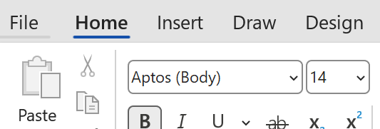

2. Click the down arrow under Pictures and choose where to get the photo:

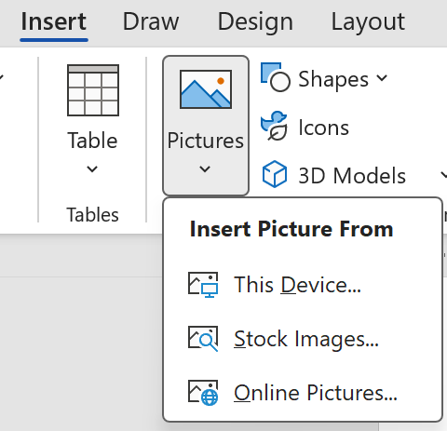

3. Choose and upload the photo.

4. To resize the photo, click on the photo to see a border and little circles at each corner. Drag one of them in and out to decrease or increase the size.
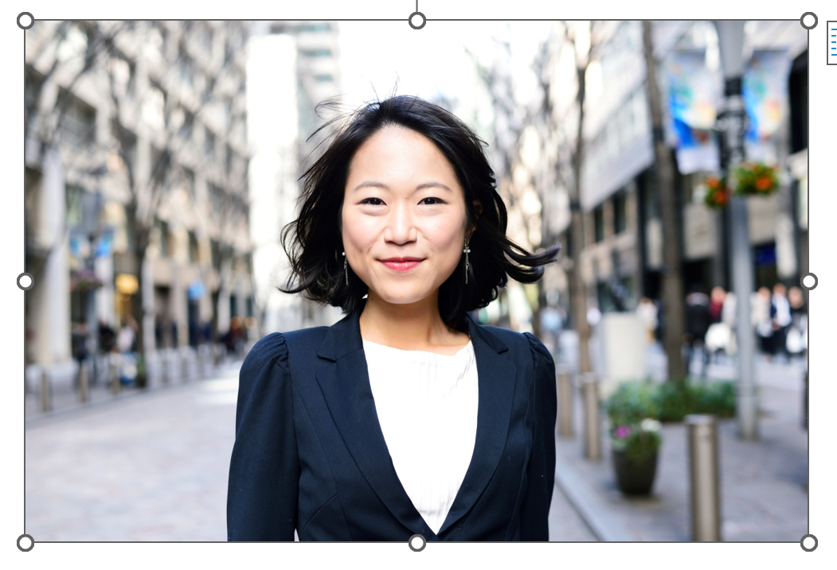

5. To move the photo, click on arrow next to it (if you hover your cursor over it, it’ll say Layout Options) and select the first one under With Text Wrapping:
